DOCKER task- 02
- Create a tomcat container on 8080 and deploy sample application in tomcat.

Step 1: Pull Tomcat Image
docker pull tomcat:9
Explanation:
* Downloads **Tomcat version 9** image from Docker Hub.
* Image will be stored locally.
* Verified using:
docker images
Shows `tomcat:9` with IMAGE ID and size
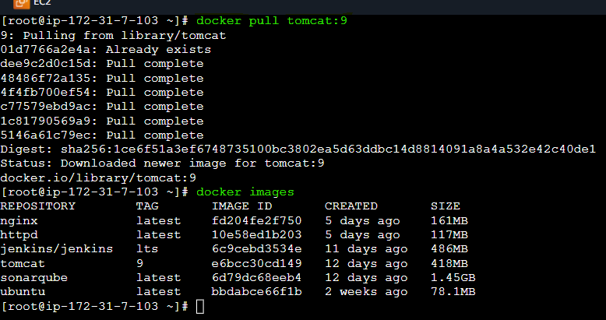

Step 2: Run Tomcat Container on Port 8080
docker run -d -p 8080:8080 --name mytomcat tomcat:9
Explanation:

* `-d` → Run container in background (detached mode)
* `-p 8080:8080` → Maps:

* EC2 Port 8080 → Container Port 8080
* `--name mytomcat` → Assign container name
* `tomcat:9` → Image used

Verify container running:
docker ps
You should see:
0.0.0.0:8080->8080/tcp

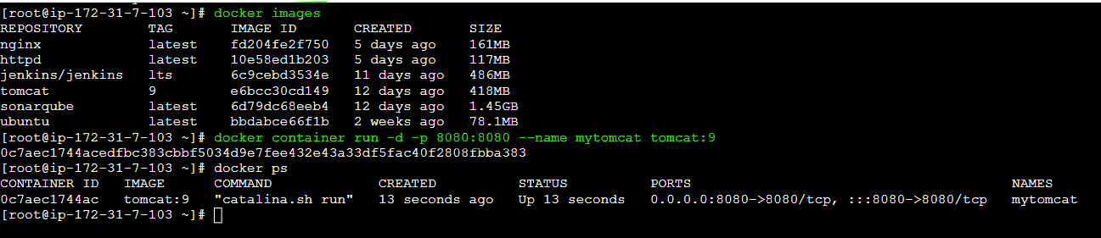

Step 3: Open Security Group (Important for EC2)
Allow inbound rule: 8080
Then access in browser:
http://<EC2-Public-IP>:8080

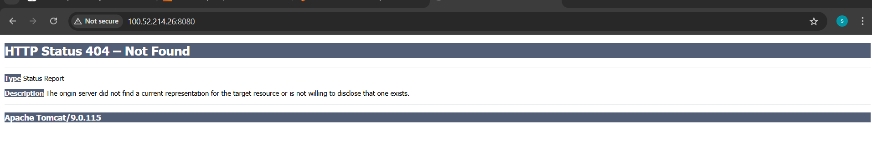
Step 4: Access Container Shell
docker exec -it mytomcat /bin/bash
Explanation:
* `exec` → Run command inside running container
* `-it` → Interactive terminal
* `/bin/bash` → Opens bash shell

Step 5: Go to Webapps Directory
cd /usr/local/tomcat/webapps
Explanation:
* `webapps` folder is where `.war` files must be placed
* Tomcat auto-deploys WAR files from this directory

Step 6: Install wget (Inside Container)

your container is Ubuntu based, so: | if container is linux based
apt update -y | yum update -y
apt install wget -y | yum install wget -y
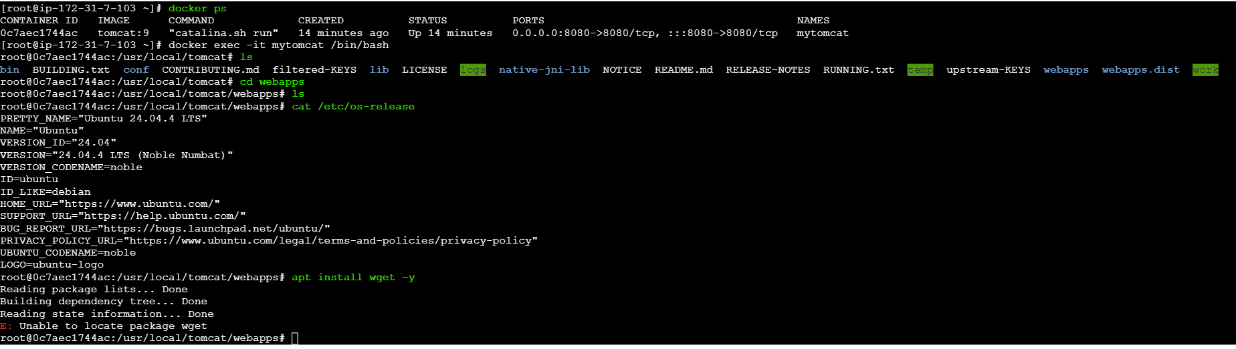
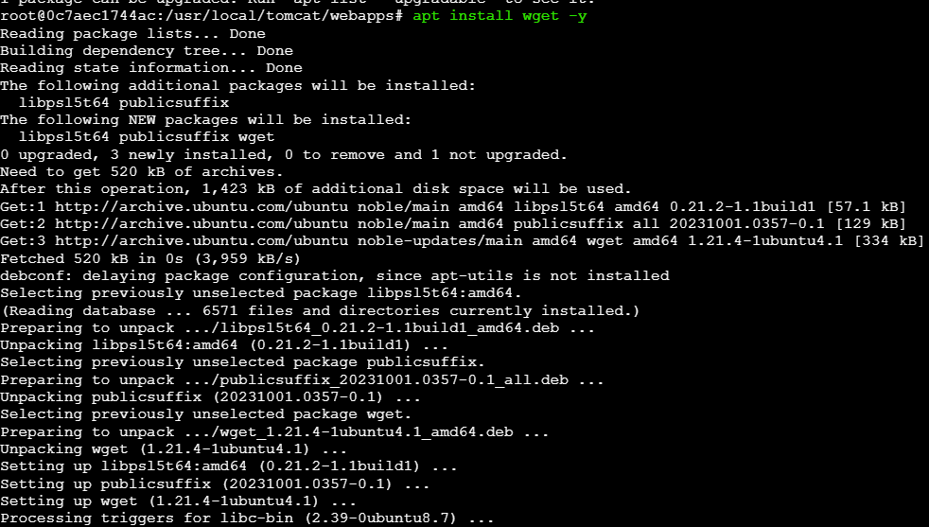
Step 7: Download Sample WAR File
wget https://tomcat.apache.org/tomcat-6.0-doc/appdev/sample/sample.war

Verify : ls
You should see:
sample.war
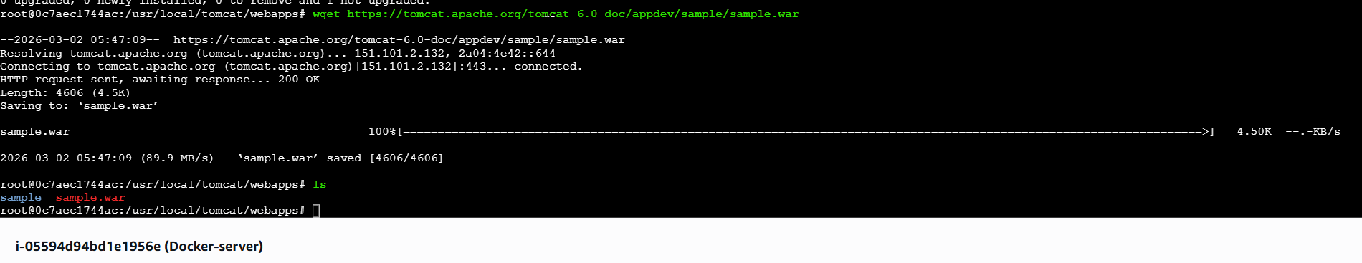
Step 8: Tomcat Auto Deploys WAR

After downloading:
* Tomcat automatically extracts `sample.war`
* Creates a folder:
sample
No restart required

Step 9: Access Sample Application

Open in browser:
http://<EC2-Public-IP>:8080/sample

You successfully see:

> Sample "Hello, World" Application
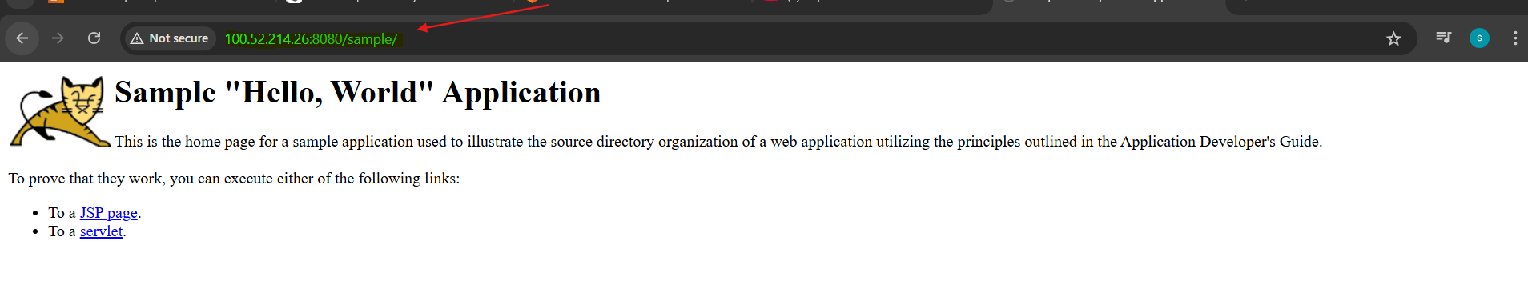

2.Create volume and deploy tomcat container on port 8081.

Step 1 : Create a Docker Volume
docker volume create tomcat -------> ( create a volume tomcat )
docker volume ls --------> ( list of volumes available )
The default location of volumes is ---> /var/lib/docker/volumes

Step 2 : Pull Tomcat Image
docker pull tomcat:9
docker images
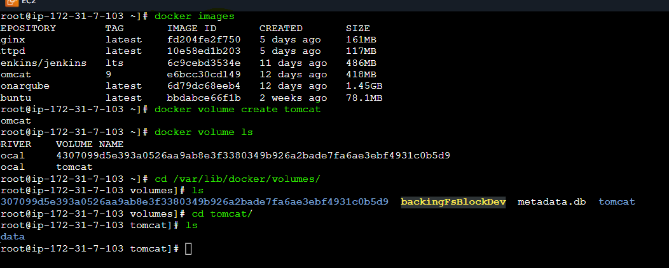
Step 3 : Run Tomcat Container on Port 8081 and attach volume created
docker run -d -p 8081:8080 -v tomcat:/usr/local/tomcat/webapps --name mytomcat tomcat:9
Explanation:

* `-d` → Run container in background (detached mode)
* `-p 8081:8080` → Maps:

* EC2 Port 8081 → Container Port 8080
* `-v tomcat:/usr/local/tomcat/webapps` → attach persistent volume
* `--name mytomcat` → Assign container name
* `tomcat:9` → Image used

Verify container running:
docker ps
You should see:
0.0.0.0:8081->8080/tcp

Step 4 : Download Sample WAR File in volume created
cd /var/lib/docker/volumes/tomcat/_data
wget https://tomcat.apache.org/tomcat-6.0-doc/appdev/sample/sample.war
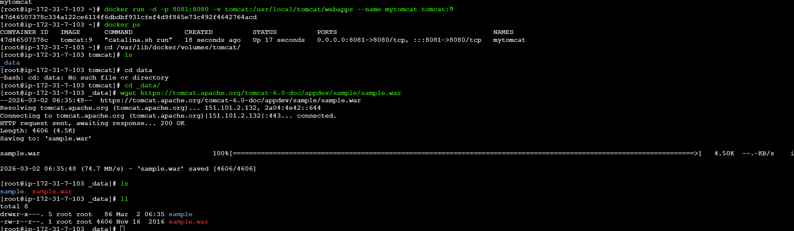
Step 5 : Open Security Group (Important for EC2)
Allow inbound rule: 8081

Step 6 : Access Sample Application

Open in browser:
http://<EC2-Public-IP>:8081/sample

You successfully see:

> Sample "Hello, World" Application
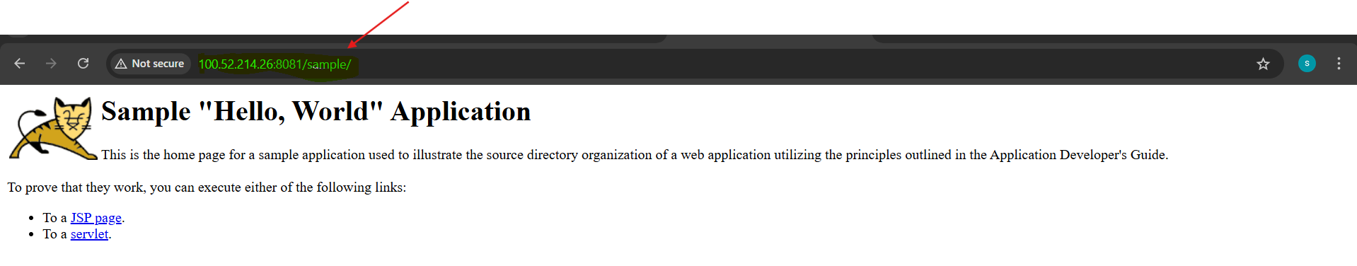
3.Limit the nginx container to 500 MB.

Step 1 : Run Nginx with 500 MB Memory Limit :
docker run -d --name nginx-limited -p 80:80 --memory=500m nginx
Explanation:

* `-d` → Run container in background (detached mode)
* `-p 80:80` → Maps:

* EC2 Port 80 → Container Port 80
* `--memory=500m` → Hard limit of 500 MB RAM
* `--name nginx-limited` → Assign container name
* `nginx` → Image used

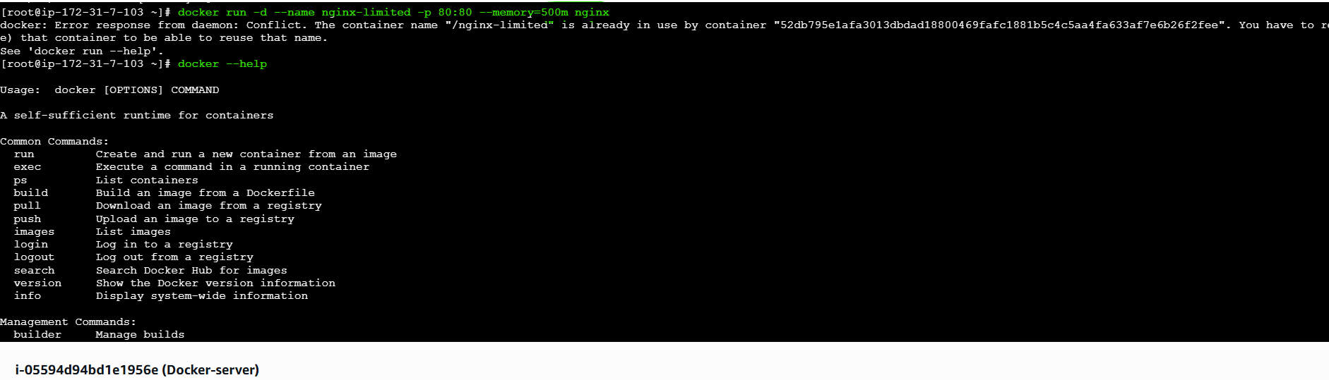

Step 2 : Verify Memory Limit
docker stats nginx-limited

4.Create a sample docker file using below instructions.
*Base module as amazonlinux:latest
*Maintainer you name
*Install nginx
*COPY one index.html file to image
*Expose on port 80
*Command to start the nginx container

Step 1: Create Dockerfile
vi Dockerfile

➤ Why?
Creates a Dockerfile where we define how our image should be built.
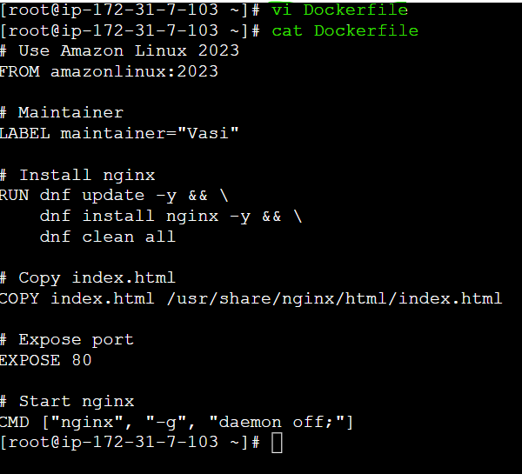

Step 2: Create index.html
vi index.html

➤ Why?
This file will be copied into nginx default web directory.

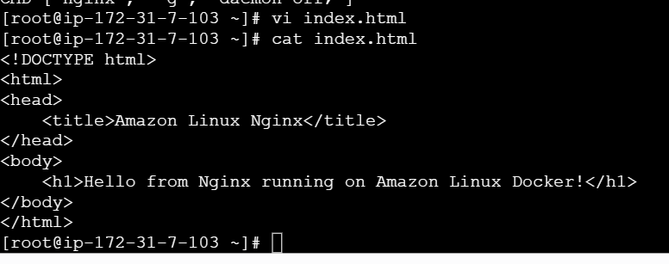
Step 3: Verify Files Exist
ls
Output should show:
Dockerfile
index.html

Step 4: Build Docker Image

docker build -t amazon-nginx .

### ➤ Explanation

| Part | Meaning |
| ----------------- | ---------------------------------- |
| `docker build` | Builds image from Dockerfile |
| `-t amazon-nginx` | Tags image with name |
| `.` | Current directory as build context |

After build:
docker images
To verify image is created.

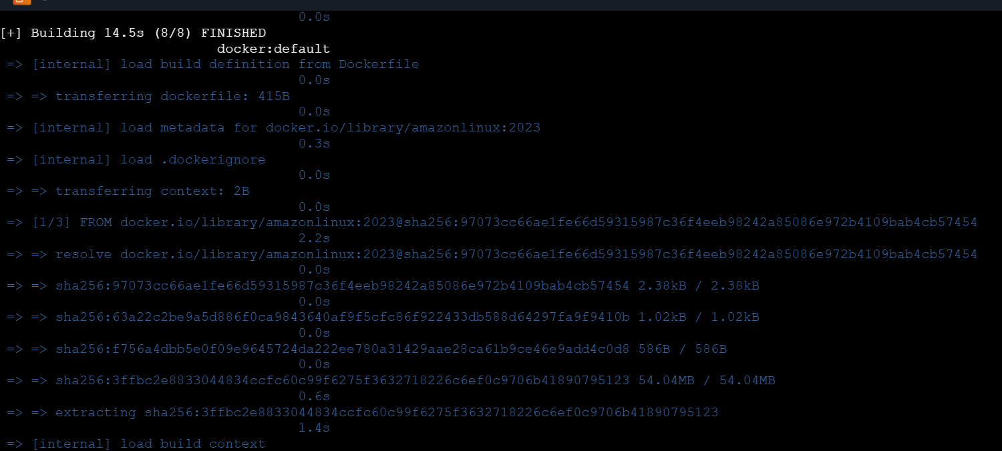
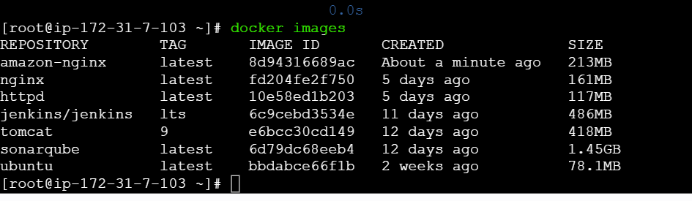
Step 5: Run Container

```bash
docker run -d -p 80:80 --name mynginx amazon-nginx
```

➤ Explanation

| Option | Meaning |
| ---------------- | ------------------------------------- |
| `-d` | Run in background |
| `-p 80:80` | Map host port 80 to container port 80 |
| `--name mynginx` | Container name |
| `amazon-nginx` | Image name |

Step 6: Verify Running Container
docker ps
Shows running containers.
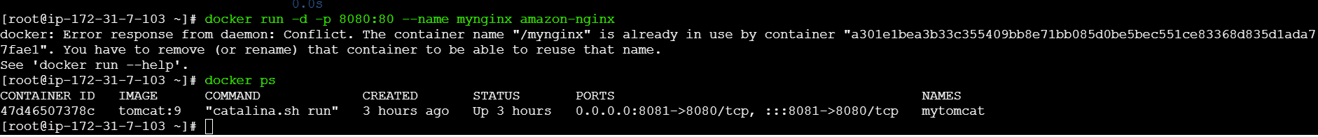
Step 7: Access Application in Browser

Open:
http://<EC2-Public-IP>
You successfully see:
Hello from Nginx running on Amazon Linux Docker!
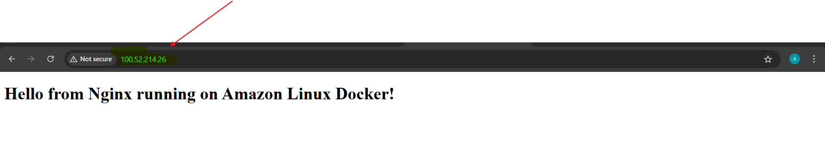
5.Push image to Docker hub

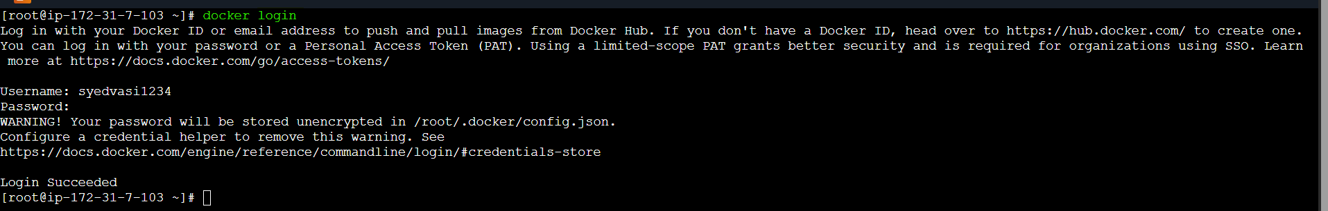
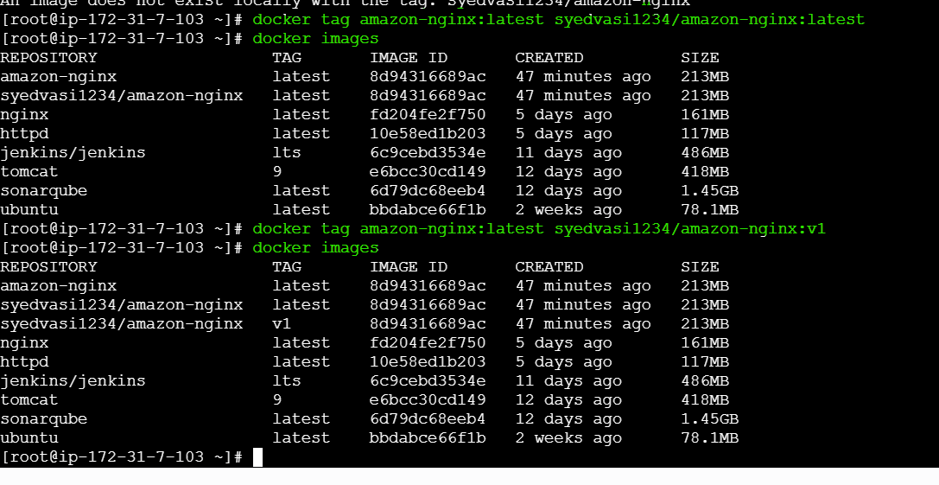
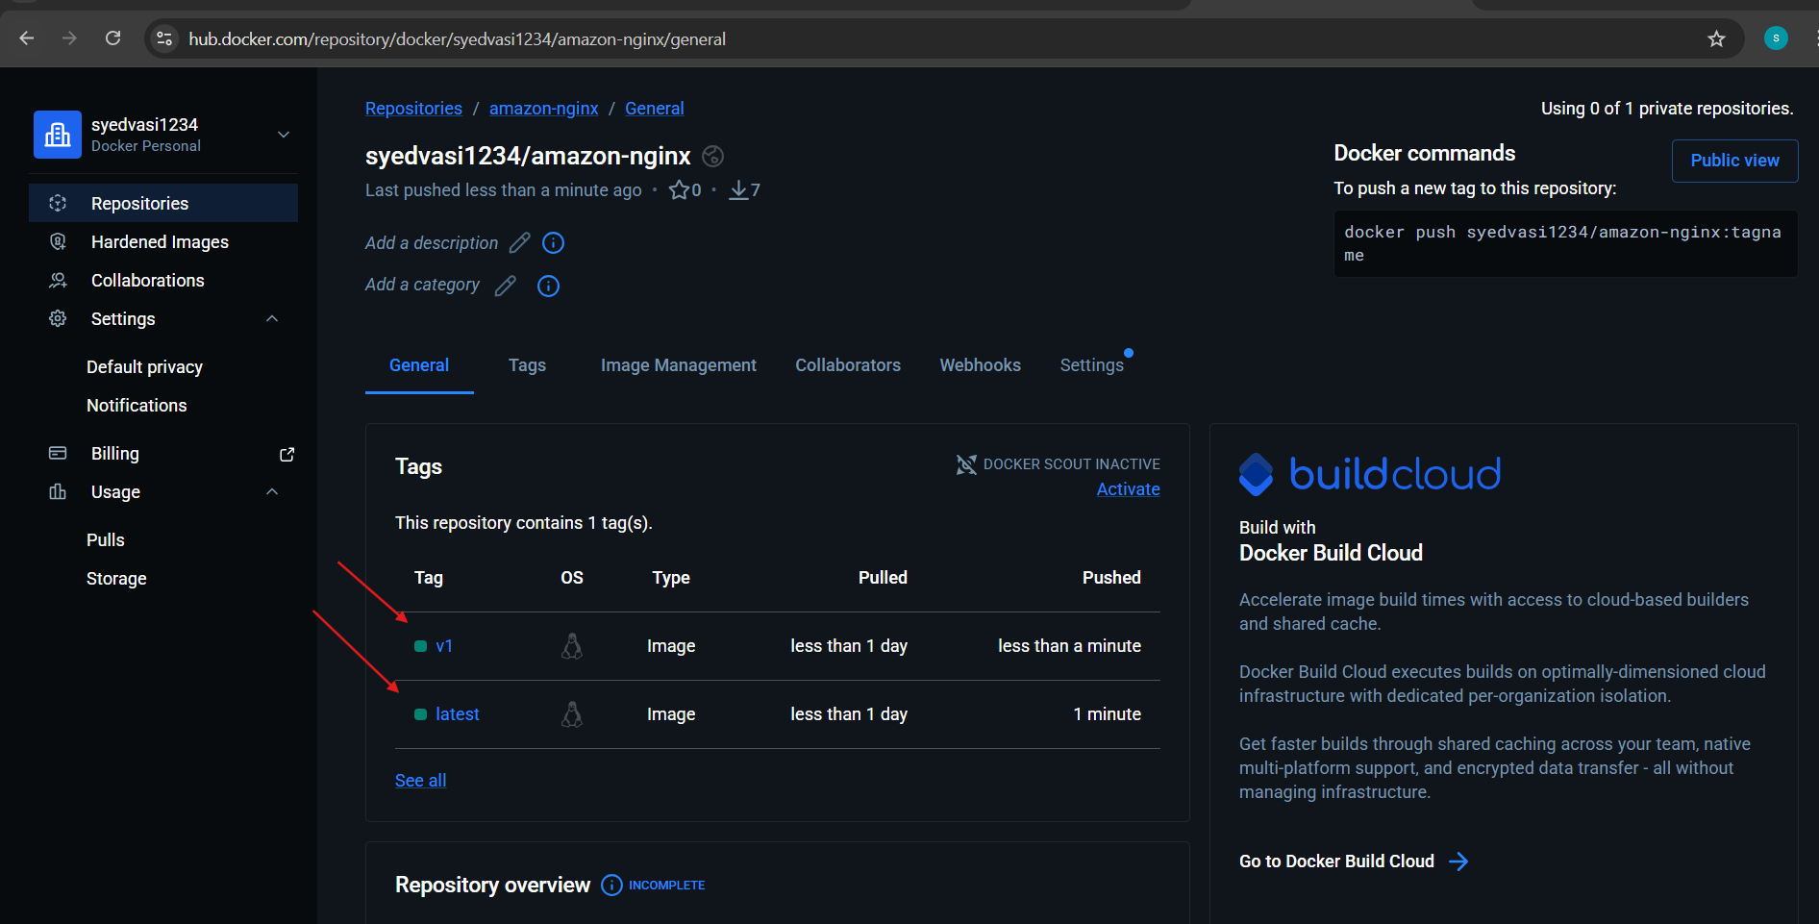
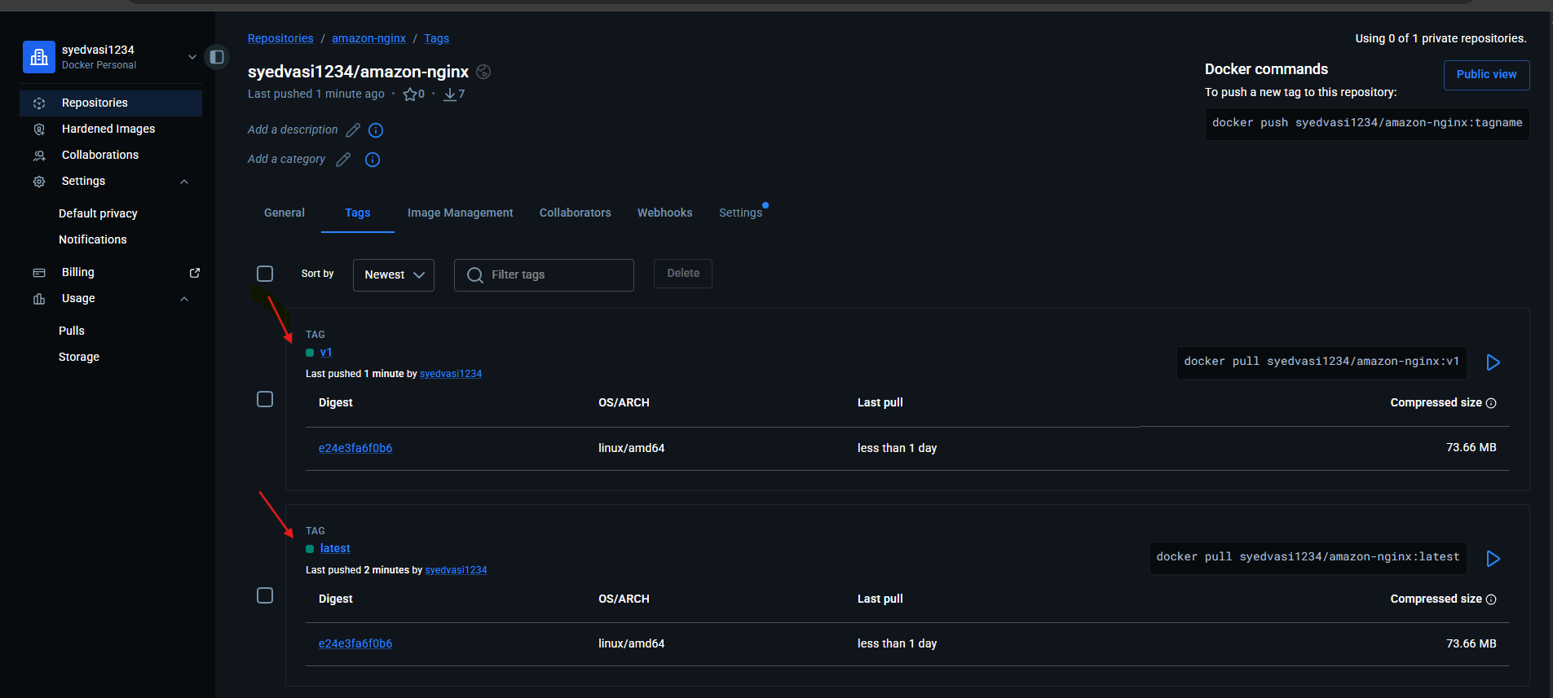

6.push image to AWS ECR

Step 1: Create ECR Repository

Go to AWS Console:
ECR → Repositories → Create Repository
Repository name: amazon-nginx
Visibility: Private
Click Create

You’ll see repository URI like:

123456789012.dkr.ecr.ap-south-1.amazonaws.com/amazon-nginx
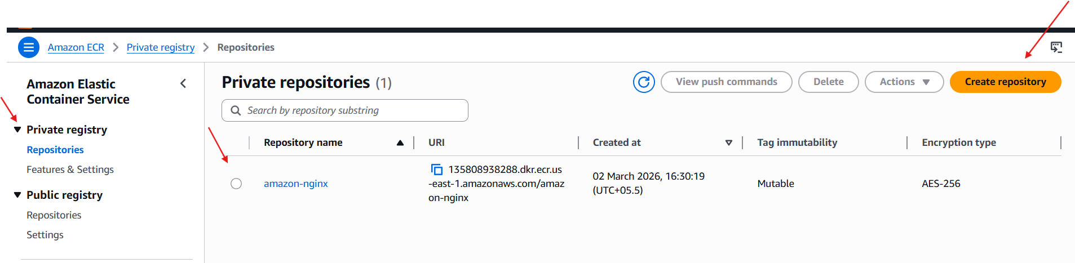
Follow the push commands shown in repository images:
